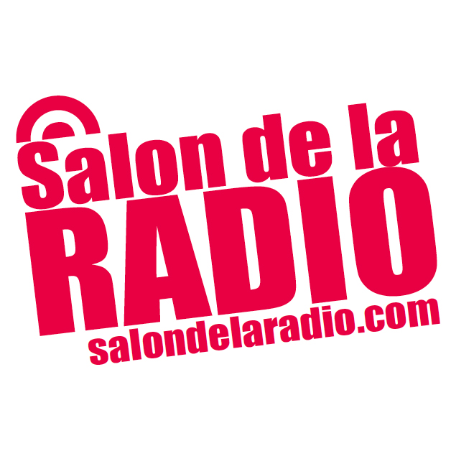

DAB+ in Europe - a vision for the future of radio

Mardi 2 février 2016 11h00 - 13h00
Salle des Débats, Grande Halle de la Villette, Espace Charlie Parker, 211 avenue Jean Jaurès, 75019 Paris

The rollout of DAB digital radio across Europe is set to continue in 2016. Norway is counting down to Digital Switchover (DSO) in 2017, Switzerland is planning for DSO, UK sees the launch of its second national commercial multiplex, and Germany, Netherlands, Italy and Denmark continue to make progress. Many car manufacturers are now offering new cars with DAB as standard.

Session produced in partnership with WorldDAB.
11:00 – 11:05 | Welcome and Introduction to the Session  Olivier Oddou, Editor-in-chief of SchooP.fr
11:05 – 11:15 | International: Digital Radio / RNT globally – status report  2016 will be an exciting year for DAB digital radio. Across Europe, momentum is building – and in the Rest of the World, there are increasing signs of interest in numerous markets.  Patrick Hannon, President, WorldDAB and Vice President Corporate Development, Frontier Silicon
11:15 – 11:25 | Commitment to Digital Radio in Germany  The German Government and public broadcaster ARD have emphasised their commitment to digital radio and the importance of working with other countries to accelerate the growth of DAB in Europe.  Helwin Lesch, Head of Distribution and Control, Bayerischer Rundfunk
11:25 – 11:35 | DAB in the UK  Digital radio has offered commercial radio in the UK the chance to grow audiences, curate content, build brands and drive revenue.  Sam Bonham, Technology Development Manager, Digital Radio UK

11:35 – 11:45 | Switzerland – a plan for Digital Switch Over 2020-2024  45% of all radio listening in Switzerland is now digital. With over 2m receivers sold, more than a quarter of radio listening is via DAB+. 60% of new cars sold have DAB+ as standard. It is no surprise then that Switzerland has developed a detailed digital switchover plan, to be achieved between 2020 and 2024. The plan includes a solution for community radio using small scale DAB+. A major focus is on marketing DAB+ digital radio to listeners.  Philippe Zahno, Président des Radios Régionales Romandes, Switzerland
11:45 – 11:55 | Italy Progress Update & Spectrum: use it or lose it  Italy shows continued steady progress on rollout of DAB+, with new services being launched regularly, and DAB+ coverage now at 68% population. Broadcasters are working together on promotion of DAB+ to the listener, also with the automotive sector on promoting digital radio in the car.  Sergio Natucci, Chief Operating Officer, Club DAB Italia
11:55 – 12:05 | Belgium – ready for an official launch in 2017  DAB+ coverage in both Flanders and Wallonia is around 95%, and there is hope for an official launch of DAB+ across Belgium in 2017.  Nicolas Bresou, Manager for Digital Radio, RTBF, Belgium
12:05 – 12:15 | The Netherlands – fast track rollout of DAB+  The Netherlands is confident that DAB+ is the FM replacement in the near future. Broadcasters are working on extending network coverage, and developing a marketing plan for digital radio.  Jacqueline Bierhorst, Project Leader, Digital Radio+ Network, The Netherlands
12:15 – 12:25 | Automotive speaker – to be confirmed
12:25 – 12:35 | The Alliance for Digital Radio / Alliance pour la radio numérique terrestre  The Alliance for Digital Radio has welcomed the CSA’s announcement in December 2015 of a timetable for the deployment of DAB across France. The Alliance is now in discussions with the CSA about accelerating its timetable.  Speaker: Olivier Ramond, President, SIRTI
12:35 – 12:45 | CSA - French Media Regulator’s perspective  At its plenary meeting on 9 December 2015, the CSA revealed a plan for more than 40 allocations, and a hundred local allocations. This announcement confirmed the CSA’s support for the digitisation of broadcast radio in France.  Patrice Gélinet, Conseiller du CSA
12:45 – 13:00 | Panel discussion

